Série de vidéos pour l’autogestion de l’AVC

Habiletés concrètes de communication post-AVC
Une fois que vous aurez regardé la vidéo sur les habiletés concrètes de communication après un AVC, veuillez consulter ces sites web et documents de référence utiles.

Ressources pour le Client & l’Entourage
- Réseau aphasie Québec https://aphasiequebec.org/
- Association Québécoise des orthophonistes et audiologistes https://aqoa.qc.ca/aphasie/
- Info AVC https://www.strokengine.ca/fr/
Ressources disponibles en anglais uniquement :
- Speech-Language & Audiology Canada – www.sac-oac.ca
- The Aphasia Institute – www.aphasia.ca
- Tactus Therapy resources – www.tactustherapy.com/learn
- Aphasia Recovery Connection – www.AphasiaRecoveryConnection.net
- Search for your provincial Speech Pathology/Audiology College

Practice Resources
- ESL Lab: Auditory comprehension of conversation with questions www.esl-lab.com
- New York Times: What’s Going On in This Picture – describing (talking or writing) and reading www.nytimes.com/column/learning-whats-going-on-in-this-picture
- News in Levels: Reading with simplified language with varying lengths www.newsinlevels.com
- Student News Daily: Longer reading with questions; can use answers for writing www.studentnewsdaily.com
- TEDEd: Listen and answer comprehension questions based on a short lecture; various topics www.ted.ed.com

Practical Post-Stroke Tutorials Aphasia Series: Communication
- Housed on Youtube currently in a playlist called “Post Stroke Tutorials” (https://www.youtube.com/playlist?list=PLlLH6D8gy0OzvkefSJsooYWgTppWZOt7K)
- Aphasia Series (Communication): Introduction - Communicating with someone with Aphasia: https://youtu.be/VQYd2spaFkI
- Aphasia Series (Communication): Tutorial 1 - Using key words to aid communication: https://youtu.be/dbapXegUFNk
- Aphasia Series (Communication): Tutorial 2 - How to use a wallet as a communication aid: https://youtu.be/EIVdaMTRHzA
- Aphasia Series (Communication): Tutorial 3 - Creating a communication binder and life story book: https://youtu.be/py4yo96B7R8

The Stroke Self-Management video series was produced as a collaboration among the following partners:

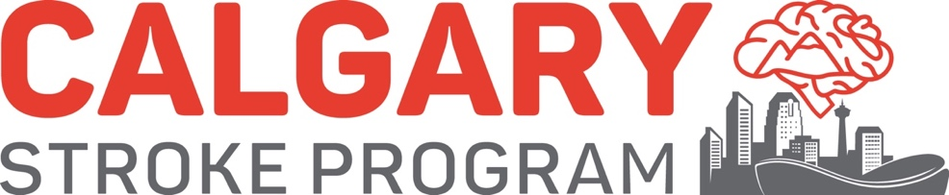

™The heart and / Icon on its own and the heart and / Icon followed by another icon or words are trademarks of the Heart and Stroke Foundation of Canada used under license.

